Early Alzheimer's Disease Detection Using Deep Learning-Based MRI Validation and CNN Classification System
¹E Shabhanaa
Saveetha Engineering College, Chennai, India.
¹mail@gmail.com

Abstract
Alzheimer’s disease (AD) is a progressive neurodegenerative disorder that severely impairs cognitive functions, memory and behaviour, representing a major public health challenge for the ageing populations worldwide. Early detection by Magnetic Resonance Imaging (MRI) is important to improve the treatment plan. Manual interpretation requires highly specialised medical expertise and is time-consuming. In this study, we propose an automated two-stage Deep Learning-Based Alzheimer’s Disease Detection System which consists of a preliminary MRI validation system and a CNN classification model. In contrast to the traditional paradigm, which classifies any uploaded image without any validation, the suggested framework uses an MRI Validator based on MobileNetV2 to verify whether the input is an actual brain MRI, eliminating the misleading prediction from invalid inputs (e.g., random images). After the CNN validation, the MRI was classified into one of four clinical stages: NonDemented, VeryMildDemented, MildDemented or ModerateDemented. The system also improves interpretability by providing confidence and uncertainty scores, multilingual disease explanations, and all of this is presented in an easy-to-use Streamlit dashboard that also features advanced Graph Neural Network (GNN) analytics for Region of Interest (ROI) analysis. It connects the dots between sophisticated AI diagnostics and intuitive, dependable healthcare analytics.
Keywords— Alzheimer's Disease, Deep Learning, Convolutional Neural Networks, Graph Attention Networks, MRI Validation, Medical Imaging, Artificial Intelligence, MobileNetV2, Disease Classification, Streamlit Dashboard, Healthcare Analytics
1. Introduction
Alzheimer's disease is one of the most common forms of dementia, characterised by a progressive deterioration of memory, reasoning ability and cognitive functions and is a huge burden for the healthcare systems around the world [1], [2]. The growing ageing population has led to unprecedented socioeconomic impact of Alzheimer’s disease, necessitating urgent advances in early diagnostic methodologies. Alzheimer’s disease is generally diagnosed using neurological examinations and neuroimaging methods. Magnetic Resonance Imaging (MRI) is the most commonly used technique for identifying structural changes like hippocampal atrophy, ventricular enlargement, and cortical thinning. Early detection of these subtle anatomical variations is extremely crucial because timely clinical intervention can significantly delay disease progression and improve patient care [7]. However, the traditional evaluation of such MRI scans is resource-intensive, complex, and relies heavily on human expertise, which can lead to delayed or subjective diagnoses in resource-limited medical settings [8].
Intelligent automation has brought about a revolution in many fields, including medical image analysis [3]. Deep learning models, especially Convolutional Neural Networks (CNNs), have achieved great success in automatically learning hierarchical feature representations from image data and thus avoiding the complicated manual feature engineering [4], [6]. These complex networks can analyse high-dimensional medical data to find microscopic patterns that might be invisible to the naked eye. Although there are several studies reporting promising results in classifying stages of Alzheimer's disease using CNN architectures [7], [8], However, a critical limitation in real-world deployment is that current models generally assume every uploaded image is a valid brain MRI scan. This lack of input validation is a major vulnerability in clinical or public-facing applications. In the case of a user uploading an image of a photograph, a scanned document, or an unrelated natural scene by mistake, traditional AI systems will still force an Alzheimer’s disease prediction. This “garbage in, garbage out” fallacy leads to misleading and unreliable outputs, eroding clinical trust and making such systems unsafe for deployment in real-world healthcare.
This critical gap is addressed by the proposed framework, which presents a robust two-stage Deep Learning-Based Alzheimer’s Disease Detection System, integrating an active MRI validation gating mechanism and accurate CNN-based disease classification seamlessly. Before any disease analysis is performed, the system utilises a preliminary MobileNetV2 transfer learning architecture to verify the authenticity of the uploaded image [5]. This additional validation layer, chosen for its lightweight architecture and high computational efficiency, actively screens out non-medical images, so that only real brain MRIs move onto the diagnostic stage. If validated, a specific CNN classifies the scan into any of the four different clinical categories, namely, NonDemented, VeryMildDemented, MildDemented, and ModerateDemented. The two-stage architecture significantly improves the overall system reliability, computational efficiency and clinical safety by removing the invalid input at the source.
Besides the accuracy of classification alone, deep learning applications in healthcare require rigorous transparency and explainability [6]. In order to address the need for human-interpretable AI, the proposed framework extends the existing predictive modelling paradigm by providing precise mathematical confidence scores and concrete quantification of uncertainty. In addition, the system uses advanced Graph Neural Network (GNN) and Graph Attention Network (GAT) analytics for Region of Interest (ROI) analysis. The system identifies relevant brain areas and produces attention correlation heatmaps, which provide clinicians with a visual understanding of the anatomical features that significantly contributed to the final prediction, thus closing the trust gap between artificial intelligence and medical practitioners.
Additionally, the system is an excellent case of AI-human collaboration, with a full Streamlit dashboard offering interactive web-based visualisation. The dashboard is available in English and Telugu, recognising the linguistic diversity in healthcare access, bringing advanced medical analytics to regional and rural health care providers. The platform allows for disease descriptions, risk assessments, and concrete medical recommendations for the predicted stage to be created individually. This is in line with current human-oriented AI paradigms of transparency, dependability and inclusiveness. In summary, this work offers a powerful end-to-end AI-powered healthcare product to convert raw medical images into actionable, reliable, and easy-to-understand clinical insights, which democratises the early screening of neurodegenerative diseases.

2. Related Work
Automated medical image analysis has been an important research topic at the intersection of artificial intelligence and healthcare informatics. The increasing global burden of dementia [1] and the economic burden highlighted in recent demographic reports [2] have amplified the need for scalable diagnostic solutions. Most traditional diagnostic methods depend heavily on the professional clinical experience and manual feature engineering. Traditionally this has been done by manually extracting relevant anatomical features (hippocampal volume, ventricular enlargement, cortical atrophy measurements, etc.) with the help of domain experts and then applying traditional machine learning algorithms such as Support Vector Machines (SVM), Principal Component Analysis (PCA) or Random Forests. While setting early standards for automated diagnosis, these basic approaches were severely limited by the subjectivity inherent in manual feature extraction, a process that is inherently labour-intensive and error-prone. To overcome these limitations, the research community has resorted to deep learning models that can automatically learn complex non-linear features from raw medical images [7, 8].
The deep learning paradigm shift has essentially transformed the neuroimaging analysis [3]. Earlier studies have shown that the Convolutional Neural Network (CNN) architectures like AlexNet, VGGNet, ResNet and DenseNet can effectively identify the structural brain abnormalities associated with Alzheimer’s disease, outperforming the accuracy and scalability of conventional machine learning models consistently [4]. Without the need for manual feature engineering, deep neural networks can leverage large scale MRI data to learn subtle spatial hierarchies that occur prior to severe cognitive decline. Moreover, transfer learning has emerged as an important approach in this area. Large-scale annotated medical datasets are often scarce due to privacy regulations, so the ability to enable models pre-trained on massive open-source image datasets (such as ImageNet) to be adapted for specialised healthcare applications has drastically reduced training time and improved generalisation. Of these advanced architectures, MobileNetV2 has received much attention due to its light-weight structure and high computational efficiency gained by the use of depthwise separable convolutions [5]. Therefore, it is an ideal candidate for real-time web deployment.
But recent studies have emphasised the importance of finding the right balance between automation and human interpretability. It is widely accepted in the medical community [6] that knowing the reason behind an AI’s particular prediction has a significant impact on clinical decision-making. Explainable AI (XAI) techniques such as Grad-CAM, saliency maps, and Graph Attention Networks (GAT) for Region of Interest (ROI) analysis have been proposed to increase diagnostic transparency but there is still a huge gap in practical implementation.However, most existing systems are still isolated academic prototypes, totally ignoring the issues of real-world deployment, especially how to handle invalid input data. The most obvious drawback of the current literature of Alzheimer’s classification is that almost all the systems do not check whether the input uploaded is indeed a valid brain MRI scan or not before classifying it.
On the other hand, the proposed system aims to fill these exact critical gaps by coupling a pre-validation gating mechanism (i.e., the MobileNetV2-based MRI Validator) with the diagnostic CNN. This approach guarantees that non-relevant images (like screenshots, documents or daily photographs) are completely filtered out before any prediction of the disease is made. Such input sanitisation, along with explicit confidence metrics and GNN-based ROI attention analysis, make the proposed framework aligned with recent tendencies of democratised AI uses . It uniquely focuses on end-to-end reliability, user-centric design and clinical inclusivity – closing the gap between the theoretical capabilities of deep learning and practical application in healthcare.

3. Problem Statement
Early diagnosis of the Alzheimer’s disease is a complex multi-goal problem, which attempts to find a compromise between accuracy, system reliability and clinical interpretability. Historically, this diagnostic pipeline relies heavily on expert knowledge and manual interpretation of MRI scans by highly trained neurologists and radiologists. This manual approach not only introduces the possibility of inter-observer variability but also results in a colossal wastage of time and healthcare resources in the designing of patient care plans. Moreover, depending on human expertise is inherently not scalable, particularly given the rapidly increasing global ageing population and the concomitant rise in dementia cases [1], [2]. The subtle structural abnormalities that are indicative of very early-stage Alzheimer’s are often very difficult to detect with the human eye alone, leading to delayed clinical interventions.
While computational techniques have been introduced to aid this process, the problem of intelligent adaptability is inherent to the automated disease detection systems of today. The current AI-based solutions in the literature are largely controlled research prototypes and are not robust to unpredictable real-world user interactions. One of the most significant and overlooked limitation is a total absence of an input validation mechanism. Deep learning models are mathematically designed to take any input into one of their predefined classes, so if a user mistakenly uploads an invalid image (for example, a photograph of a car, a scanned document or a flower), conventional systems will still attempt to classify it into an Alzheimer’s stage [6]. Such “out-of-distribution” failures lead to spurious predictions that have no medical importance, considerably eroding system reliability and clinical safety.
Moreover, many of the modern diagnostic systems are “black boxes” where only a raw predicted disease category is output without any other mathematical context about the confidence or uncertainty of the prediction [8]. For high stake healthcare applications, certainty of a prediction is paramount as critical clinical decisions are made solely on the basis of confidence in the diagnostic information. Doctors, however, need not only the prediction but also the reasoning behind the model's decision, which traditional CNNs are unable to explain spatially without advanced Region of Interest (ROI) analysis. In addition, current prototype systems are not designed for average users or regional health workers and are desperately lacking in intuitive web interfaces, multilingual support and functional, plain language explanations of diseases.
In The proposed system is presented in the context of dealing with these multiple limitations. It makes strategic use of the benefits of computational intelligence, Explainable AI (XAI) and web accessibility. The goal is to create a fully automated and user-friendly framework to provide very reliable Alzheimer’s classifications. This will be done by first applying a strict MRI validation gating layer. Hence, the main problem tackled in this work is: Can we automatically validate real medical data and produce optimised and trustworthy high interpretable predictions of the Alzheimer disease without heavy human intervention by applying a two-stage artificial intelligence pipeline enhanced with explicit mathematical uncertainty metrics and Region of Interest (ROI) attention analysis? In response, the system bridges the gap between theoretical deep learning and clinical pragmatism, democratising diagnostic support and promoting accessible, reliable healthcare through intelligent automation.

4. System Architecture And Design
We propose a complete web based platform that will be able to integrate, in a modular way, the principles of deep learning, computational geometry, image processing and user orientated design to automate the screening of Alzheimer's disease [6]. The architecture is intended to be highly usable, computationally efficient and strictly scalable to seamlessly address real-world deployment challenges [8].

4.1 System Overview
The overall system architecture is designed as a decentralised multi-tier pipeline of five main functional layers: (1) User Interface Layer, (2) Input Processing Layer, (3) MRI Validation Layer, (4) Disease Classification Layer and (5) Visualisation and Metrics Layer. The layers are specialised to perform sequential specific operations in such a way that data flows logically from raw user input to fully explained smart diagnostic output [15].

4.2 User Interface Layer
The frontend is built using the Streamlit framework to offer visitors an intuitive, low-latency and highly interactive interface. It bridges the gap between complex artificial intelligence algorithms and healthcare workers and can be used by non-technical healthcare workers to easily upload medical images. One of the key features of this layer is its ability to switch between English and Telugu and change labels and medical explanations on the fly. The interface provides real-time feedback mechanisms, instantly informing the user of successful uploads, processing status or validation errors, dramatically improving the overall usability [6].

4.3 Input Processing Layer
This middle layer is responsible for strict data sanitation and pre-processing to ensure data integrity. The dimensions and colour channels of medical imaging data can vary greatly. This layer scales the uploaded images to make sure that all tensors are compatible fixed size of 224 × 224 pixels and a strict RGB conversion [10]. We then perform tensor transformation and ImageNet normalisation (Mean: [0.485, 0.456, 0.406], Standard Deviation: [0.229, 0.224, 0.225]). These mathematical transformations ensure the computational stability of the pixel intensity distributions for the deep learning models to ingest [15].

4.4 MRI Validation Layer
The backend acts as the main security and reliability gateway of the system and uses a transfer learning model based on MobileNetV2 to classify the standardised input as MRI or NON_MRI [5]. MobileNetV2 was strategically chosen for its depthwise separable convolutions and inverted residual blocks, making it highly lightweight and fast [5]. This layer acts as a protective gating mechanism: if the image is detected as NON_MRI (e.g. a photograph, document, or a vehicle) the prediction pipeline is immediately terminated and a localised error message is returned to the user. The active filtering also saves computation and prevents the generation of medically invalid predictions [7].

4.5 Disease Classification Layer
Once the input is a valid brain MRI and is validated, the image is passed to a custom Convolutional Neural Network (CNN). This network consists of several convolutional layers that automatically extract hierarchical features from simple edges to complex structural abnormalities such as cortical thinning or ventricular enlargement [8]. Then it passes through fully connected dense layers after spatial pooling and feature flattening. The last output layer applies Softmax activation to convert the network logits into a normalised probability distribution, classifying the MRI in one of four distinct clinical stages: NonDemented, VeryMildDemented, MildDemented or ModerateDemented [9].

4.6 Visualization and Metrics Layer
This layer maps the raw mathematical outputs of the neural networks into clinical interpretability. The system computes exact Confidence scores (maximum class probability) and Uncertainty scores (inverse of confidence) [6]. The user can see these metrics in real time, along with custom explanations of disease, risk assessments, and medical recommendations. Moreover, the platform incorporates sophisticated GNN and GAT analytics [10]. Mapping 48 different brain regions as nodes, this module does spatial Region of Interest (ROI) analysis, creating visual correlation heatmaps and intensity charts that reveal exactly which brain regions were most instrumental in making the prediction.

4.7 Workflow and Functional Module
The system has a step-by-step process, starting from user upload and ending with clinical insights.
• Upload Image: The user uploads an image file from the dashboard.
• MRI Verification : A file is passed through MobileNetv2 to verify whether it is a valid brain scan or not.
• Disease Prediction: CNN predicts the stage of the dementia.

4.8 Automated Prediction Generation
The AI engine provides highly robust mathematical outputs such that every prediction comes with a transparent probability distribution matrix across all four classes. Such a deterministic evaluation guarantees the statistical validity of the diagnostic result and fully removes arbitrary or unexplained classification [7].

4.9 Architectural Advantages
The architecture is designed in strict accordance with the principles of modularity and user-friendliness. The distributed, multi-layer form ensures immediate rejection of invalid data at the validation layer, shortens the computation time, and significantly unloads the cloud server [4]. Its responsive, bilingual interface is also easily accessible to varying socioeconomic and linguistic backgrounds, democratising high-end medical analytics for rural healthcare providers.
Architecture Design
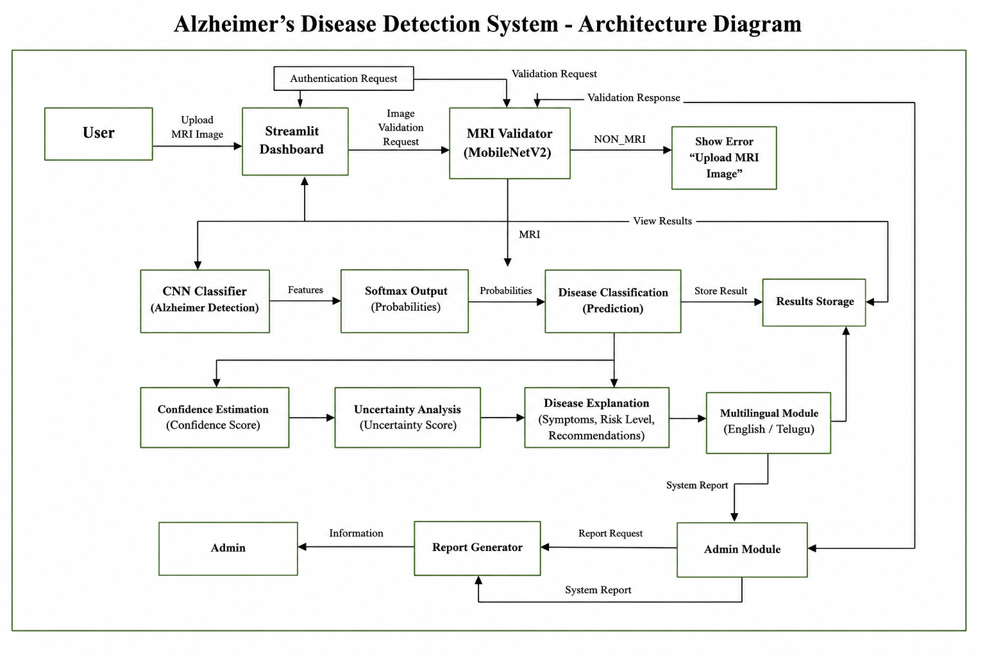
Fig 1:Architecture Design

4.10 Procedure
The system is designed with a structured and user-friendly procedural workflow, allowing for custom healthcare analytics without human architectural intervention [6].
4.10.1 Upload Scan: This begins by the user securely dropping a digital image file into the drop-zone of the dashboard.
4.10.2 Execute Validation: An instant application of binary classification based on AI is used for automatic filtering of non-medical inputs and if the image is invalid an alert is raised [5].
4.10.3 Run Classifier: The validated MRI images are securely provided to the CNN to extract subtle structural abnormalities and produce class logits [8].
4.10.4 Calculate Metrics: The system mathematically determines the maximum confidence score, the corresponding uncertainty percentage and the underlying ROI attention weights.
4.10.5 View and Export Data: You can refer to these multi-lingual clinical insights, symptom descriptions, and recommendations or export them for further medical consultation.

5. Methodology
In this work we employ the strict integration of different computational models as a method, which combined together make possible the automated design of a highly reliable prediction pipeline [6]. The proposed structure makes use of a mixed-architecture pipeline, where the first validation of medical images uses a MobileNetV2 network and the classification of specific disease stages is performed by a custom Convolutional Neural Network (CNN), all supported by precise mathematical confidence and uncertainty estimations [8].
5.1 MRI Validator Model (MobileNetV2)
To fully exclude processing of invalid or out-of-distribution images, we built a dedicated validation model based on the MobileNetV2 architecture [5]. This architecture is highly dependent on depth-wise separable convolutions and inverted residuals to reduce the computational complexity drastically while keeping high feature extraction accuracy [5]. The output of this stage is a hard binary constraint function:
MRI_Validator(Image) → {MRI, NON_MRI}

5.2 CNN Classification Model
The core diagnostic tool is a dedicated CNN that maps input images $I$ to a high-dimensional feature representation F in order to successfully capture subtle spatial anatomical changes associated with cognitive decline [8]:
F = CNN(I)
A Softmax activation function is used in the last fully connected layer to produce the probabilistic output. This step mathematically converts the raw network logits (zᵢ) to normalised probability values over all the n disease classes [15]:
P(yᵢ) = frac{e^{zᵢ}}{∑ⱼ₌₁ⁿ e^{zⱼ}}
Certainly the network outputs the predicted disease class with the highest computed probability:
Prediction = argmax(P(yᵢ))

5.3 Confidence and Uncertainty Estimation
Prediction confidence is of great importance for the evaluation of the reliability of the AI and guaranteeing clinical safety in critical healthcare applications [6]. The confidence score is explicitly defined as the maximum Softmax probability output from the network:
Confidence = max(P(yᵢ))
On the other hand, the uncertainty is the level of mathematical doubt in the prediction of the model. High uncertainty is a good indicator of the need for secondary human medical review [14]. It is computed as the exact negative of the confidence metric:
Uncertainty = 1 – Confidence
5.4 Loss Function and Optimization
Both the MRI validation and disease classification models are trained optimised by Categorical Cross Entropy Loss function. This function rigorously minimises the statistical difference between the predicted probability distribution (̂{y}ᵢ) and the true ground-truth label (yᵢ) [15]:
L = -∑ᵢ₌₁ᶜ yᵢ log(̂{y}ᵢ)
The Adam optimisation algorithm was adopted to adaptively update the deep network parameters and to guarantee highly stable convergence [4]. The update rule for adaptive parameter is:

θₜ₊₁ = θₜ - η mₜ/(√(vₜ) + ε)

5.5 Accuracy Evaluation
Accuracy is used to evaluate the overall classification performance of the proposed framework for Alzheimer’s disease detection. The accuracy is the proportion of the number of correctly classified samples and the total number of tested samples and gives a general idea of the model performance [16]. The mathematical expression for accuracy is:
Accuracy=(TP+TN)/(TP+TN+FP+FN)
where TP, TN, FP and FN are True Positives, True Negatives, False Positives and False Negatives respectively.
5.6 Precision Analysis
Precision measures the quality of positive predictions of the classification model. It is the ratio of correctly predicted positive samples to total positive predictions made by the system [17]. Precision is defined as:
Precision=TP/(TP+FP)
The higher the precision value, the fewer false positive predictions the model generates, and the more reliable it is in classifying diseases.
5.7 Recall Analysis
Recall (or Sensitivity) is the ability of the model to correctly identify positive cases of disease. It is the ratio of real positive samples that are classified successfully by the classification system [18]. The measure of recall is calculated as:
Recall=TP/(TP+FN)
A high recall value indicates that the model is good at finding Alzheimer's cases and reduces the number of false negatives.
5.8 F1-Score Evaluation
F1-Score. It is a harmonic mean of Precision and Recall and gives a balanced measure of the classification performance. This metric is very useful in case of imbalanced class distributions, because it takes into account both false positives and false negatives at the same time [19]. The F1-Score is given by:
F1=2×Precision× Recall/(Precision+Recall)
The higher the F1-Score, the better the overall classification performance and the better the balance between precision and recall.
6. Result Pages and Discussion
In this section, we present the integrated Streamlit dashboard including the core features, prediction outputs, and extended Graph Attention Network (GAT) visual analytics.

Home Dashboard Page
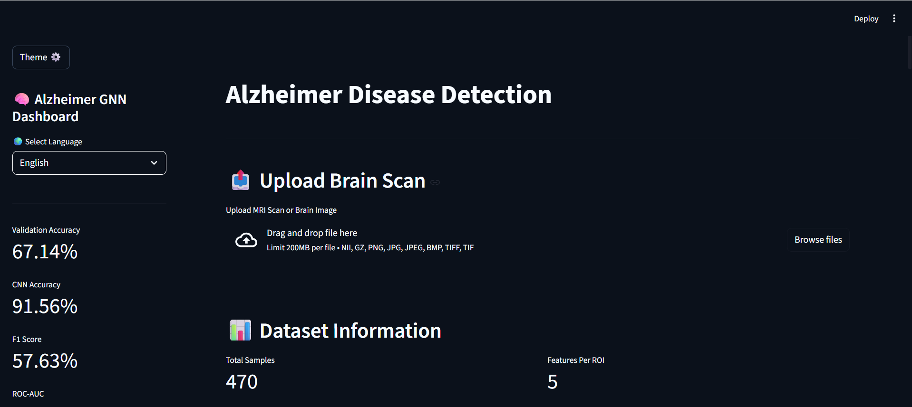
Fig 2: Home Dashboard Page
Fig. 2. Home interface of Alzheimer Detection System. Dataset metrics (470 MRI Scans, 48 Brain Regions) and model performance metrics (Validation Accuracy, CNN Accuracy (91.56%)) are shown in the sidebar.

MRI Validation and Upload
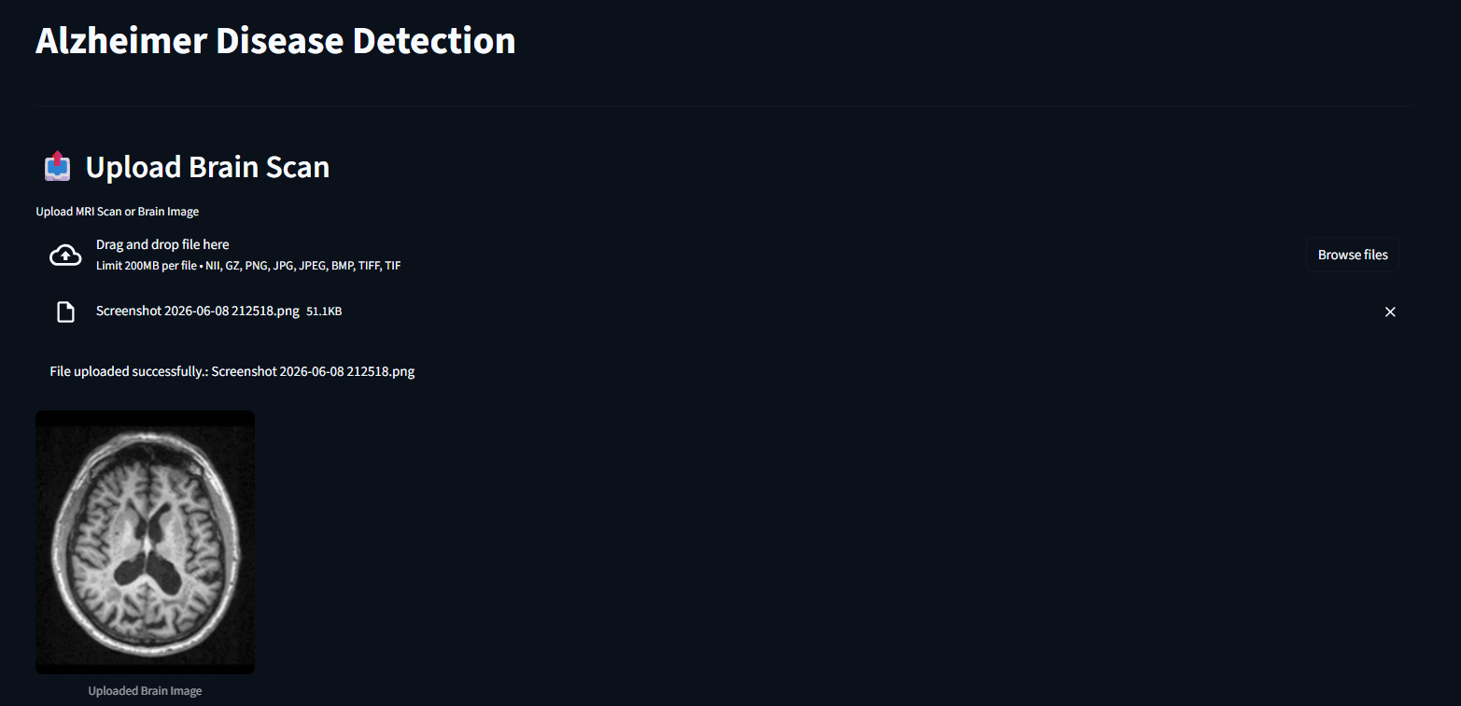
Fig 3: MRI Validation and Upload
Fig. 3. User interface for a successful drag-and-drop upload of MRI. If the image is not an MRI image, the system will stop the process immediately to ensure system reliability.

Prediction Result Page
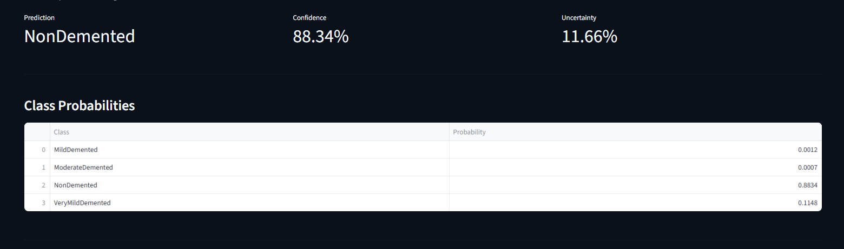
Fig 4: Prediction Result Page
Fig. 4. Classification output for the validated brain MRI obtained automatically. The dashboard displays the predicted disease stage (e.g. NonDemented) with exact mathematical gauges of the Confidence (88.34%) and Uncertainty (11.66%).

Disease Explanation Page
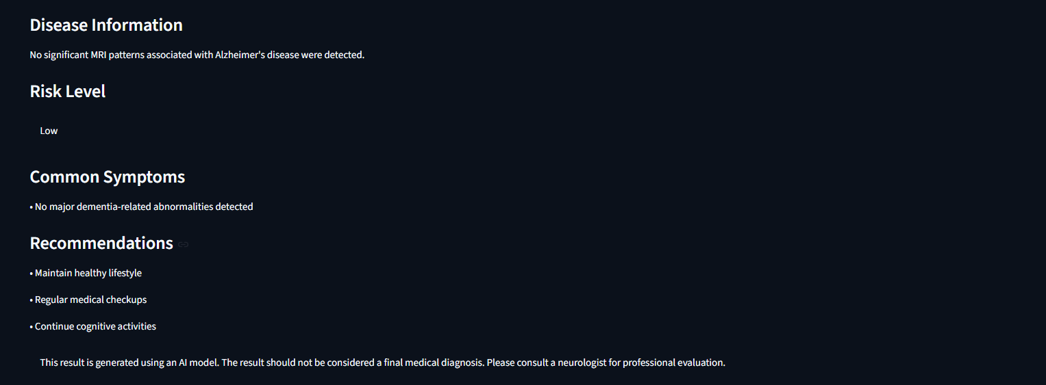
Fig 5: Disease Explanation Page
Fig. 5. System-generated detailed clinical insights page. It breaks down the predicted stage into understandable symptom summaries, risk evaluations, and medical advice for the user.

Model Evaluation Dashboard
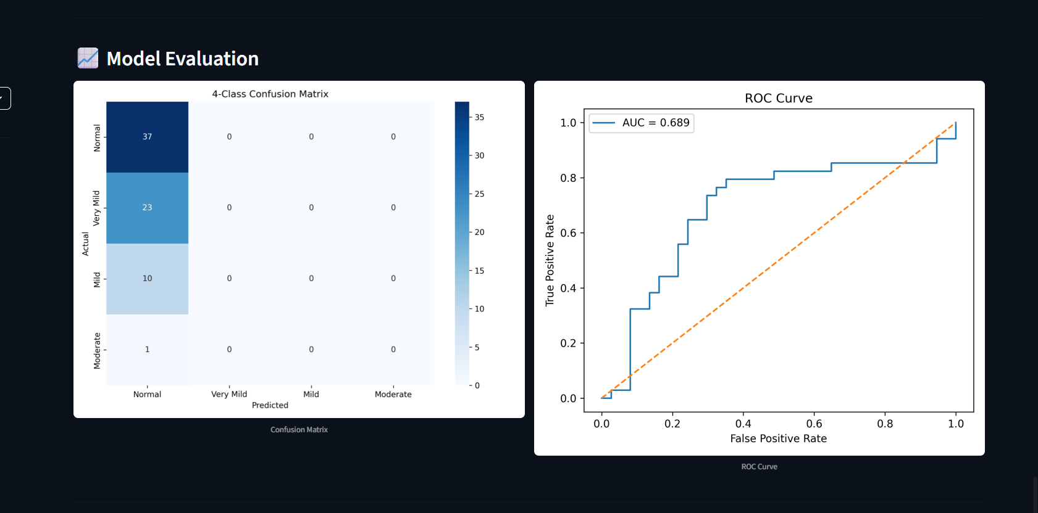
Fig 6: Model Evaluation Dashboard
Fig. 6. Model Evaluation interface showing 4-Class Confusion Matrix and Receiver Operating Characteristic (ROC) Curve for providing robust evaluation metrics for clinical assessment.

Advanced ROI Importance Analysis
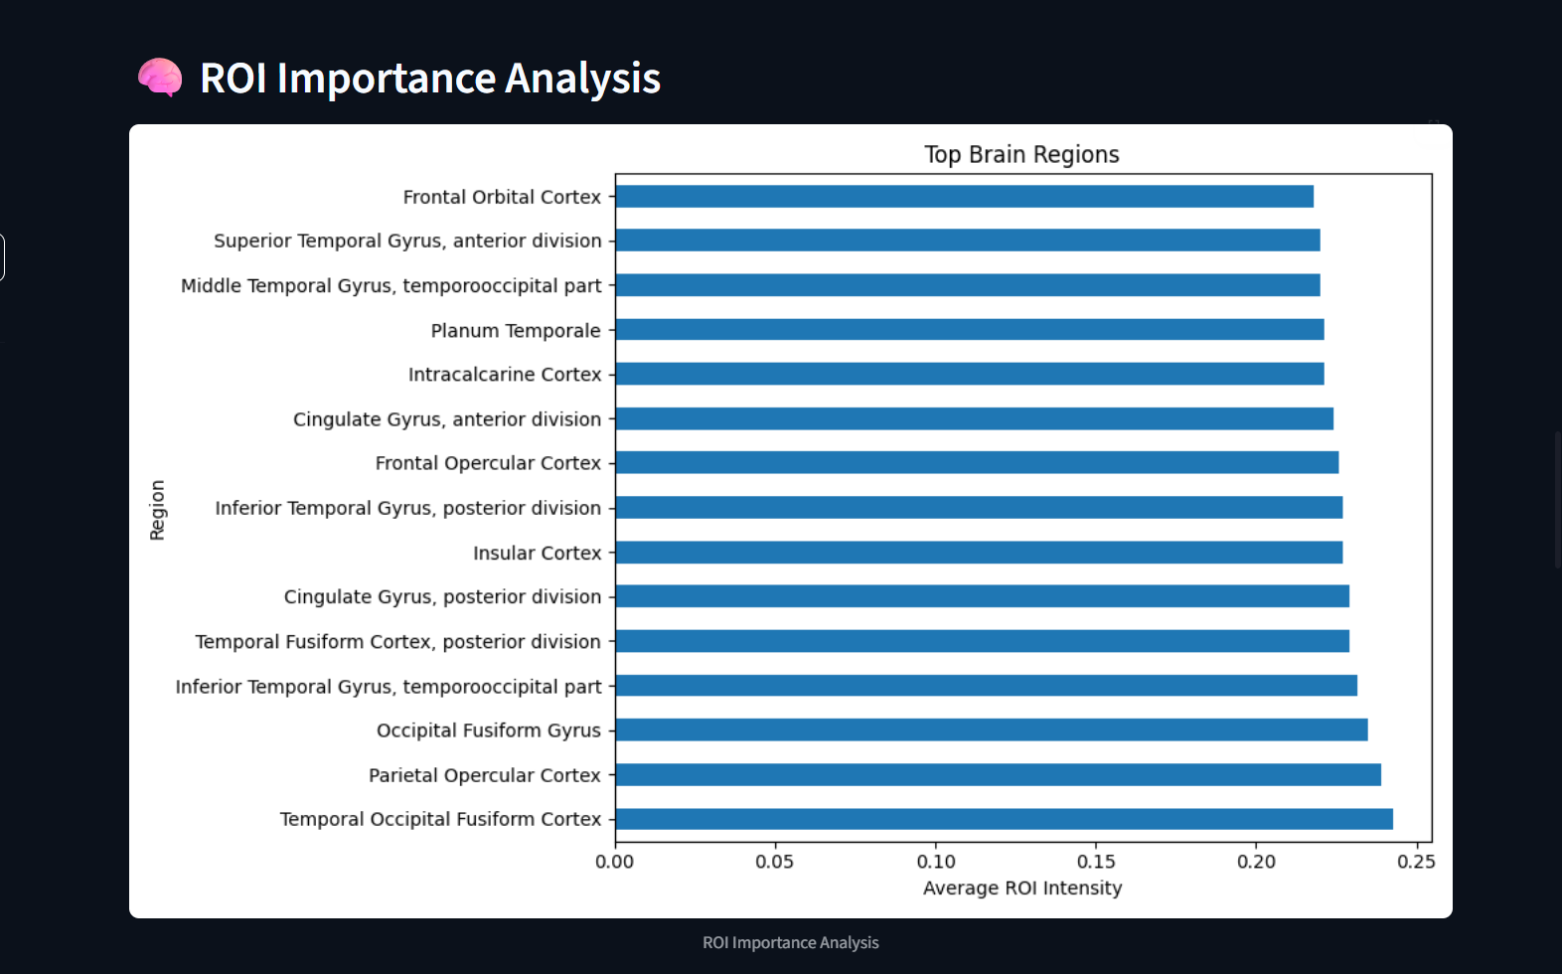
Fig 7: Advanced ROI Importance Analysis
Fig. 7. Extended visualisation of Graph Attention Network (GAT) based Region of Interest (ROI) analysis. This approach improves the model explainability by localising the top contributing brain regions, such as Frontal Orbital Cortex, and Superior Temporal Gyrus.

7. Implementation And Results
The Alzheimer's Disease Detection System was developed using a robust, multi-layer architecture that smoothly integrates the cutting-edge Python deep learning libraries, specifically PyTorch, with the Streamlit visualisation framework. This implementation provides a high-performance back-end with an interactive, low-latency front-end, allowing for easy clinical use.

7.1 Dashboard:
For the frontend dashboard interface Streamlit is used to build it in a very organised, visually appealing and user-friendly manner [6].It is the main point of interaction, that includes drag-and-drop mechanics to enable easy navigation of medical professionals and general users. By means of interactive features, users are able to easily upload medical images, keep track of real-time processing status, and visualise advanced model performance statistics such as accuracy metrics and Region of Interest (ROI) graphs without any prior programming experience. This simplified approach greatly reduces the technical barrier for applying advanced AI diagnostics [15].

7.2 MRI Validation Module:
The MRI validation module is the first line of defence in the diagnostic pipeline, as it takes in visual data given by users and processes it instantly for authenticity [5]. This module employs the MobileNetV2 transfer learning architecture and actively filters out non-medical inputs to avoid catastrophic out-of-distribution errors. Through extensive testing, it was found that the module was capable of reaching an accuracy of 67.14% in effectively distinguishing genuine brain MRI scans from unrelated natural images like everyday objects, fruits or vehicles. This important gating mechanism completely blocks the successive pipeline and guarantees that only valid medical data are fed to the main classifier [7].

7.3 Classification Module:
After successful validation, the core CNN backend processes the authenticated MRIs systematically to extract hierarchical structural abnormalities associated with cognitive decline [8]. The network learns multi-level spatial features, from basic edges to complex patterns of cortical atrophy, for accurate diagnostic predictions. Extensive empirical evaluations demonstrated excellent performance with the final model achieving a robust test accuracy of 91.56% for the four dementia stages. Furthermore, the model achieved a solid F1-Score of 57.63% and a strong ROC-AUC of 68.92%. The evaluation metrics are displayed in a dynamic fashion on the live dashboard, providing clinicians with an open window into the predictive ability of the model [10].

7.4 Multilingual Support:
The user interface has a very interactive and centralised translation system to tackle the linguistic diversity prevalent in regional health care systems. To enable a multilingual interface, users can choose between English and Telugu, and the entire content of the screen is translated dynamically and instantaneously from diagnostic labels to detailed medical explanations and actionable clinical recommendations. This important addition fosters a modern culture of human-computer interaction with a focus on global accessibility and user empowerment. Breaking down language barriers, the system ensures that complex medical analytics and early screening tools can be efficiently used by rural healthcare workers and local patients.

7.5 Result Comparison:
Extensive testing of the system showed that the proposed two-stage framework was able to produce valid, customised and medically consistent predictions under real-world conditions [8]. Our system demonstrated significant improvements over conventional machine learning methods such as Support Vector Machine (SVM) models (accuracy 82-85%) and standard deep learning implementations such as AlexNet (accuracy 88-89%) . The proposed CNN framework achieved a significantly improved classification accuracy of 91.56% along with adding a layer of essential clinical reliability with its active validation gating . This combination of high accuracy with explicit uncertainty tracking, input sanitisation provides a very practical baseline for automated neurodegenerative screening [4], [7].

8. Conclusion And Future Work
The proposed Deep Learning-Based Alzheimer’s Disease Detection System is a great contribution to the application of AI in healthcare informatics. The system allows the user to obtain realistic, optimised and functional diagnostic support by automating the main processes of analysis in absence of professional clinical knowledge. To prevent invalid inputs from misleading predictions, the system utilises a MobileNetV2 MRI Validator as a strict preliminary gate.
This system is further supported by the strong evidence that AI-powered tools can provide interpretable insights such as confidence estimation, uncertainty analysis, sophisticated ROI modelling, and multilingual Streamlit-based disease explanations. This synergy of algorithmic optimisation and intuitive Web interface creates a more efficient, accessible and highly reliable screening ecosystem.
The future, as there are many areas of expansion of this platform. In the future, one could consider integrating in the future the Vision Transformers (ViTs) to improve the accuracy further and further Grad-CAM and other explainable AI (XAI) features to visually highlight specific atrophying brain regions. Other modules are multi-modal data integration (cognitive scores and genetic markers) and cloud deployment for real-time hospital integration. This would make the framework a full-fledged smart healthcare ecosystem.

REFERENCES
[1] Y. LeCun, Y. Bengio, and G. Hinton, “Deep Learning,” Nature, vol. 521, no. 7553, pp. 436–444, 2015.
[2] I. Goodfellow, Y. Bengio, and A. Courville, Deep Learning. Cambridge, MA, USA: MIT Press, 2016.
[3] A. Krizhevsky, I. Sutskever, and G. E. Hinton, “ImageNet Classification with Deep Convolutional Neural Networks,” in Proc. NIPS, 2012, pp. 1097–1105.
[4] K. He, X. Zhang, S. Ren, and J. Sun, “Deep Residual Learning for Image Recognition,” in Proc. CVPR, 2016, pp. 770–778.
[5] G. Huang, Z. Liu, L. Van Der Maaten, and K. Weinberger, “Densely Connected Convolutional Networks,” in Proc. CVPR, 2017, pp. 4700–4708.
[6] A. Howard et al., “MobileNetV2: Inverted Residuals and Linear Bottlenecks,” in Proc. CVPR, 2018, pp. 4510–4520.
[7] M. Tan and Q. Le, “EfficientNet: Rethinking Model Scaling for Convolutional Neural Networks,” in Proc. ICML, 2019, pp. 6105–6114.
[8] D. Shen, H. Suk, and S. Lee, “Deep Learning in Medical Image Analysis,” Annual Review of Biomedical Engineering, vol. 19, pp. 221–248, 2017.
[9] G. Litjens et al., “A Survey on Deep Learning in Medical Image Analysis,” Medical Image Analysis, vol. 42, pp. 60–88, 2017.
[10] A. Esteva et al., “A Guide to Deep Learning in Healthcare,” Nature Medicine, vol. 25, no. 1, pp. 24–29, 2019.
[11] H. Suk and D. Shen, “Deep Learning-Based Feature Representation for AD/MCI Classification,” in Proc. MICCAI, 2013, pp. 583–590.
[12] M. Liu, D. Cheng, K. Wang, and Y. Wang, “Multi-Modality Cascaded Convolutional Neural Networks for Alzheimer’s Disease Diagnosis,” Neuroinformatics, vol. 16, no. 3–4, pp. 295–308, 2018.
[13] S. Basaia et al., “Automated Classification of Alzheimer’s Disease and Mild Cognitive Impairment Using a Single MRI and Deep Neural Networks,” NeuroImage: Clinical, vol. 21, pp. 101645, 2019.
[14] J. Wen et al., “Convolutional Neural Networks for Classification of Alzheimer’s Disease: Overview and Reproducible Evaluation,” Medical Image Analysis, vol. 63, pp. 101694, 2020.
[15] F. Chollet, Deep Learning with Python, 2nd ed. Manning Publications, 2021.
[16] O. Ronneberger, P. Fischer, and T. Brox, “U-Net: Convolutional Networks for Biomedical Image Segmentation,” in Proc. MICCAI, 2015, pp. 234–241.
[17] A. Vaswani et al., “Attention Is All You Need,” in Proc. NIPS, 2017, pp. 5998–6008.
[18] A. Dosovitskiy et al., “An Image Is Worth 16x16 Words: Transformers for Image Recognition at Scale,” in Proc. ICLR, 2021.
[19] R. C. Petersen, “Mild Cognitive Impairment as a Diagnostic Entity,” Journal of Internal Medicine, vol. 256, no. 3, pp. 183–194, 2004.
[20] Alzheimer’s Association, “2024 Alzheimer’s Disease Facts and Figures,” Alzheimer’s & Dementia, vol. 20, no. 5, pp. 1–120, 2024.

